November 1st, 2020

Report – Homework_1 – Kickstarter campaigns

1. **Given the provided data, what are three conclusions we can draw about Kickstarter campaigns?**

* The top successful categories were film &video, music and theater; followed very closely by technology; however, the sample was not the same in all sub-categories, that can determine what the interest are around the world and how there is a common ground on what they like, those categories have been very successful through out the years and it’s a very good indicator in what the focus is around the world.
* The sub-categories on those 3 mentioned categories on top that were the most successful because they capture most of the sub-categories which validates what the focus of people is around the world. Now a days self-entertainment is a big key in developing any campaign to be successful, another important fact is when campaigns were successful which there is a slightly difference and during the whole year those were very tight on their success rate, only may spike up and then December spikes down, since is when people are more likely on vacations, traveling, shopping and focusing in different activities.

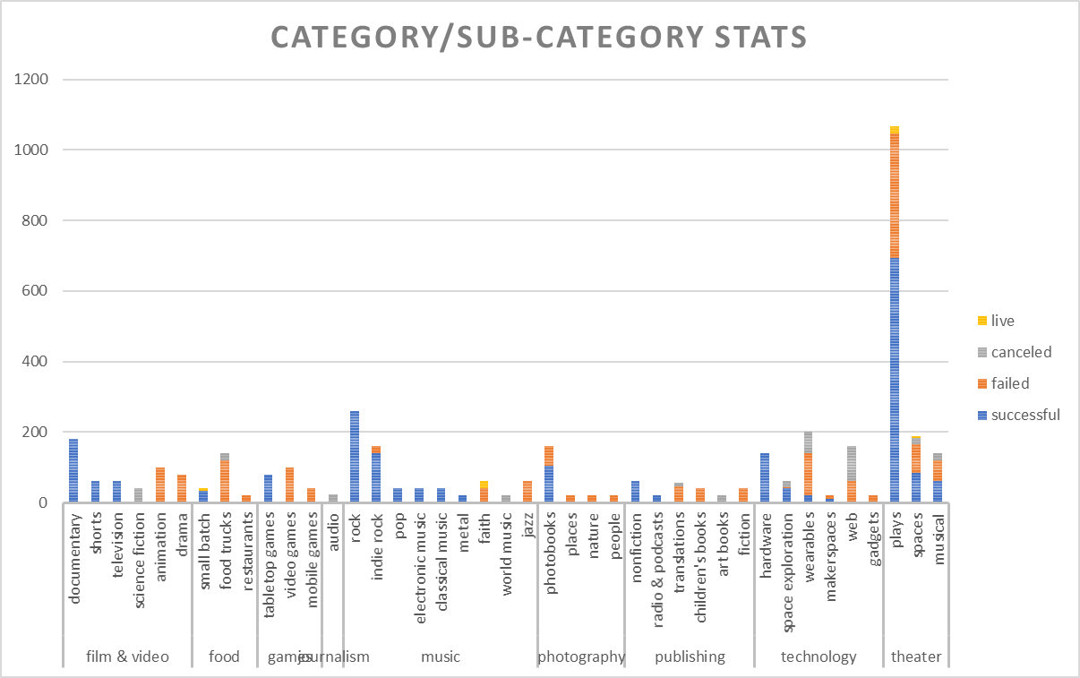

* We can also see how the successful rate is averagely a 46% and it cannot be consider as a good indicator since over all the failed percentage average to 42% they are very tight, the success was on the small goal campaigns and the ones that failed were the big campaigns, in addition to this, the cancellations were 12% which goes incrementing align with the challenge of the size of the goal. The higher goal the higher risk.

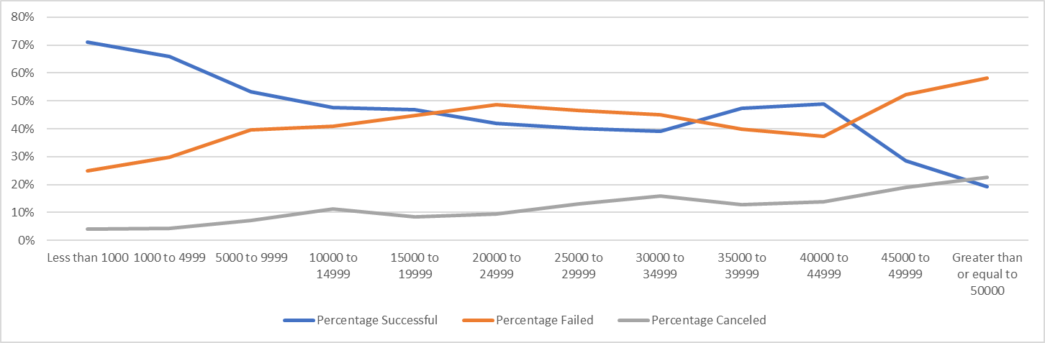

1. **What are some limitations of this dataset?**

* I do not know the range or parameters used to get the information that is shown, what sector or market was use for the objective, what was the objective, components and goals of the campaigns.
* Here is where the storytelling plays a noticeably big role because it gives me the ins and outs of the scenario to be able to provide a concrete and effective analysis with the results obtained. Even more complicated with he data so spread out which might be challenging when trying to sort it out and see what made it successful, understand what made it failed, and then deep drive and to get an actual focus on what is really positive since those were approximately half the counts.

1. **What are some other possible tables and/or graphs that we could create?**

* Analyze the countries and use one currency, I would choose USD and convert all the money into it to have a real comparison of what was successful.
* Also, the length of the study when it got created versus when it concluded to know what is the mean time and evaluate how that would affect the results as well, e.i. if having more time from when the campaign was created and ended will make a difference.
* Analyze by currency, country, category and sub-category the rate of the campaigns kick-off; who did each evaluation if it was the same agency around the world or several ones, and being able to define if any criteria was used to get a positive result that was more subjective than how it truly needs to be objective.